Forest Estate Community Hub

Hourly Hire Rates | One off  Private events  Eg: parties/clubs/celebrations | Regular Scheduled bookings  (10 or more) | Commercial | Business Start-up Package *
Main Hall & Kitchen | £18 | £16 | £25 | £18
Entire Venue  (Main hall, kitchen & rear area) | £28 | £26 | £35 | £28
Hire Rates for 2019

* Terms and conditions apply
Half and Full Day Rates | Main Hall and Kitchen | Entire Venue  (main hall, kitchen & rear area)
Half Day  4 hours am or pm | £85 | £120
Full Day | £145 | £195

Additional Charges for use of equipment

Projector & screen – per day |  | £15
Easel and Flipchart pad |  | £10
Facilitation boards/screens  6 available (W120 cm x H150 cm ) | 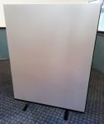 | £5 ea
Table top boards  4 available (180cm x H90cm) | 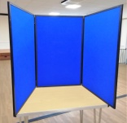 | £5 ea
Beverage Bundles

1 bundle includes:
Tea bags
Instant coffee
Filter coffee
Sugar
Sweet biscuits
Milk

Also provided are 8 x 1lt pump flasks, 3 x kettles, mugs, spoons
We estimate one bundle should make x numbers of hot drinks
Litre bottles of fruit squash can be provided at an additional cost

